**User Guide**

1. **Sign In Page**

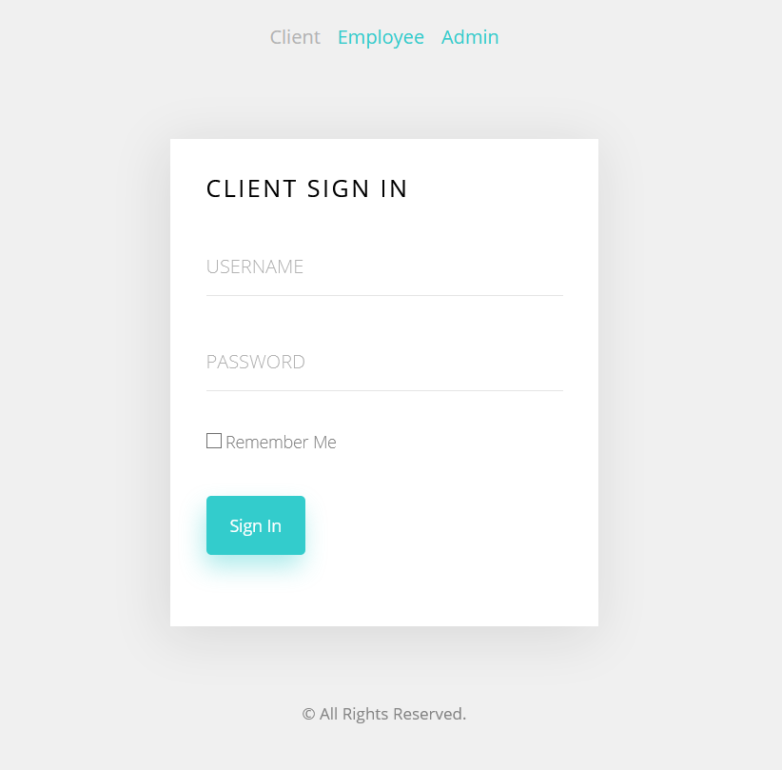

**In this page client and Employee can sign in with their ID and password. Admin account can be signed in by Email and password.**

**Simply click the button in the top can switch the sign in page to different user.**

**2.Client Page**

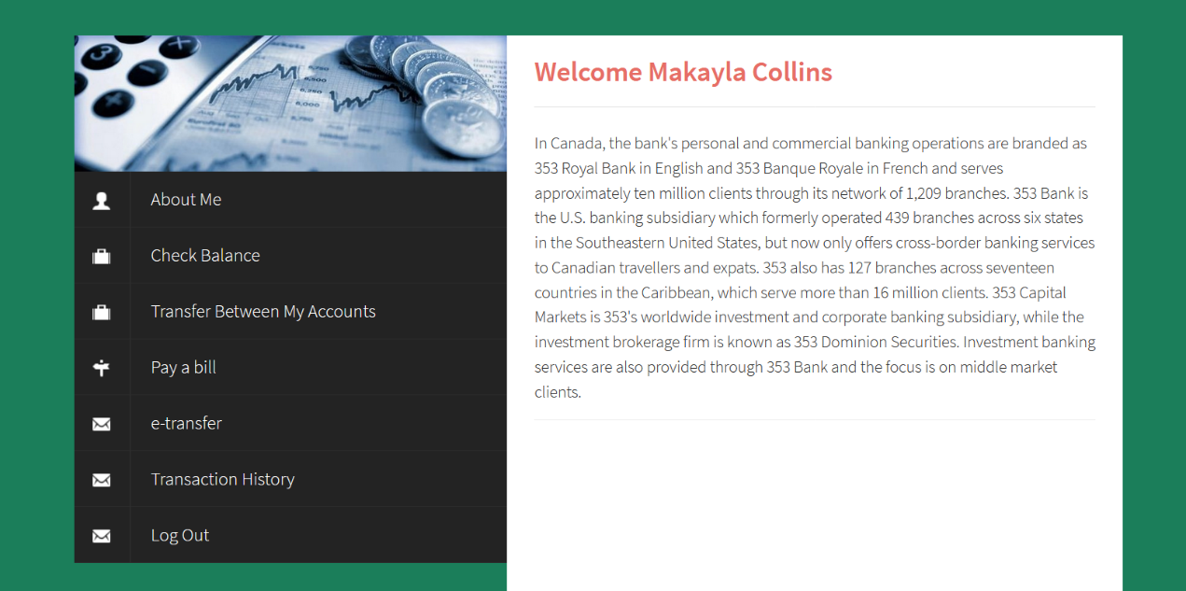

**Application Included:**

* **About Me—Check and edit client information**

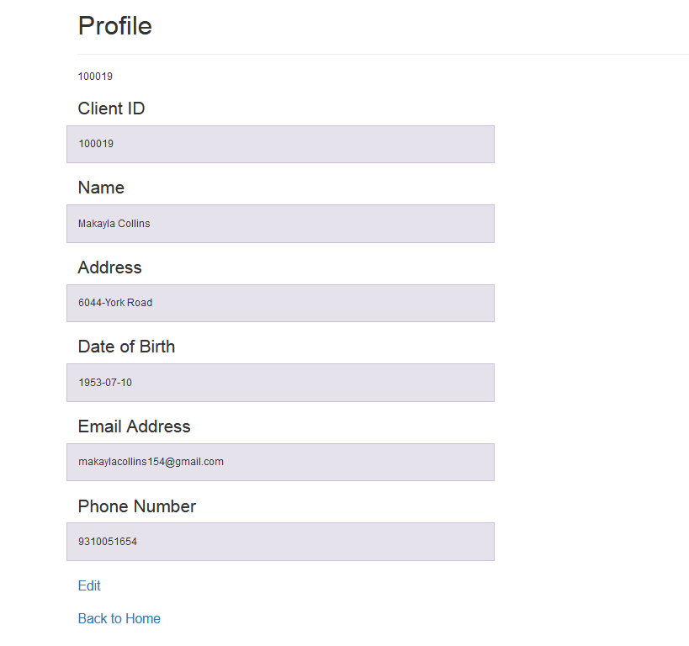

* **Check Balance—See details of the client’s account(number, balance..) and move money within accounts.**

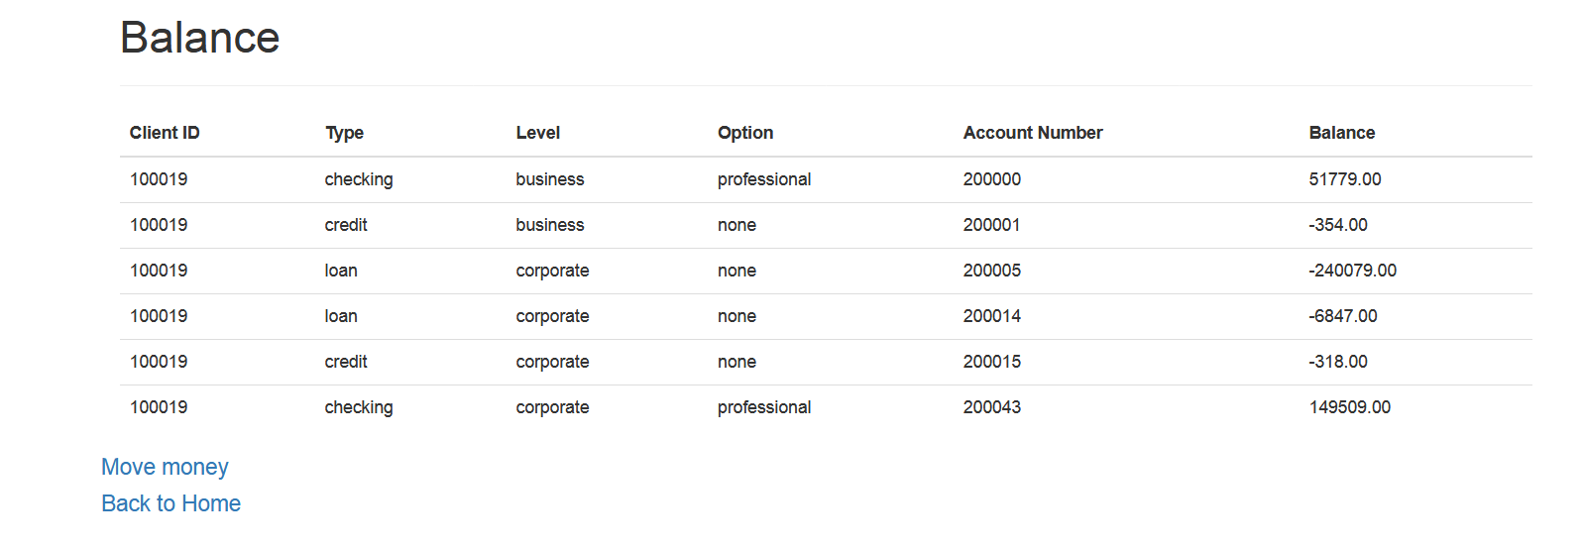

* **Transfer Between My Accounts—Move money within accounts.**
* **Pay a bill—Pay a bill instantly or set regular payment.** 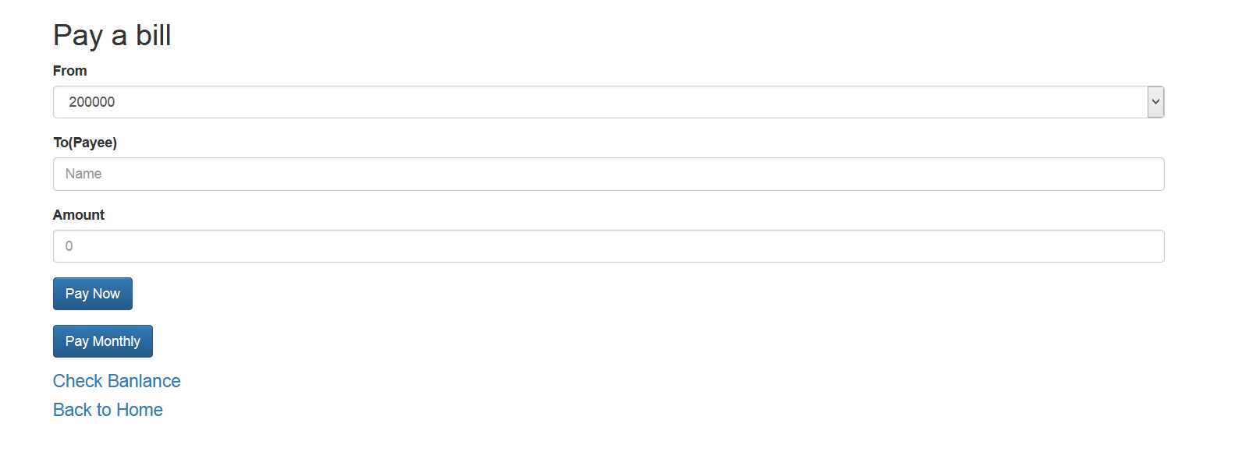
* **e-Transfer—Send money to other clients by using email or phone number.**

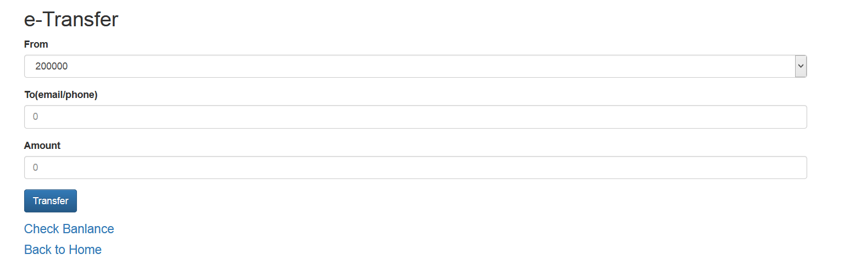

* **Transaction—View the transaction within 10 years. And any e-transfer or pay bill will be added into transaction history.**

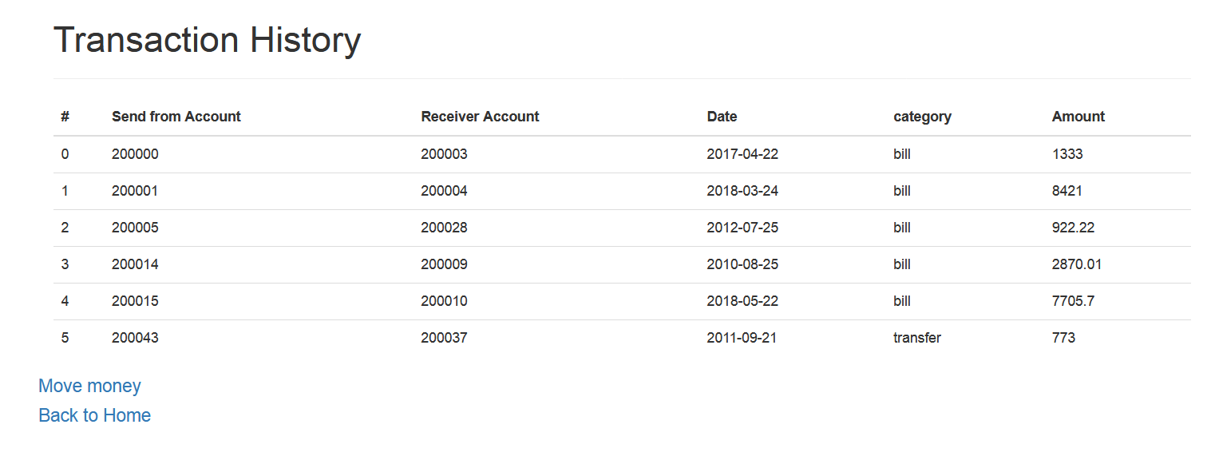

* **Log out—Exit the system**

1. **Employee Page**

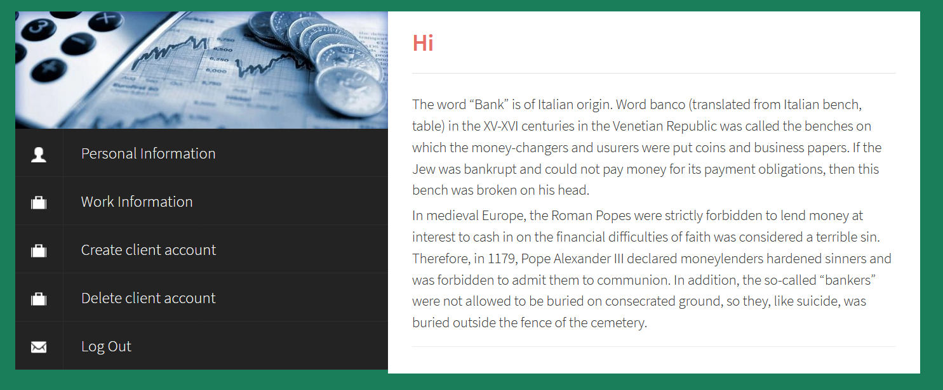

**Application Included:**

* **Personal Information—Check and edit employee information**

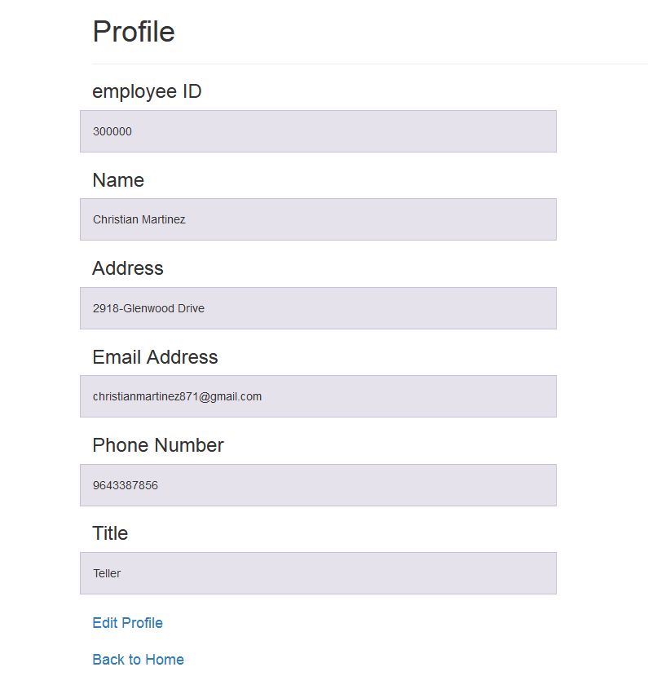

* **Work Information—check work information(salary ,schedule,branch id…)**

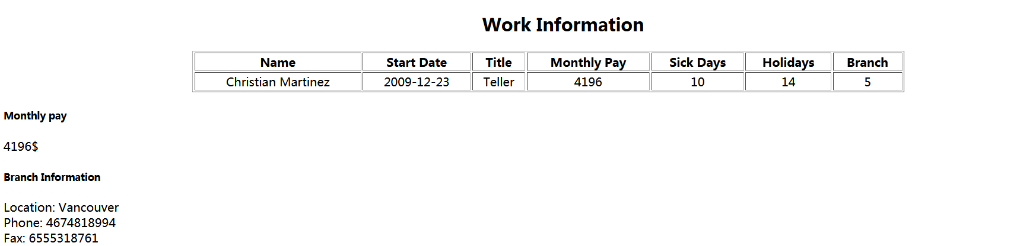

* **Create client account—create accounts for clients by entering corresponding information**

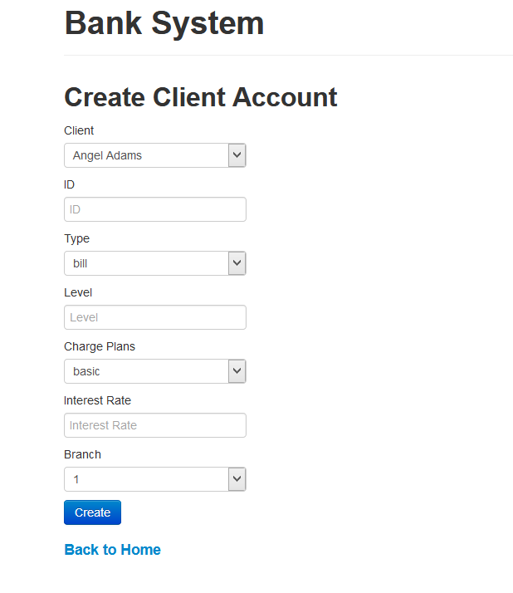

* **Delete client account—delete accounts for clients by entering corresponding information**

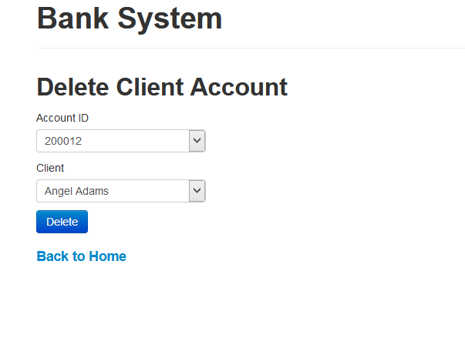

**3.Admin page**

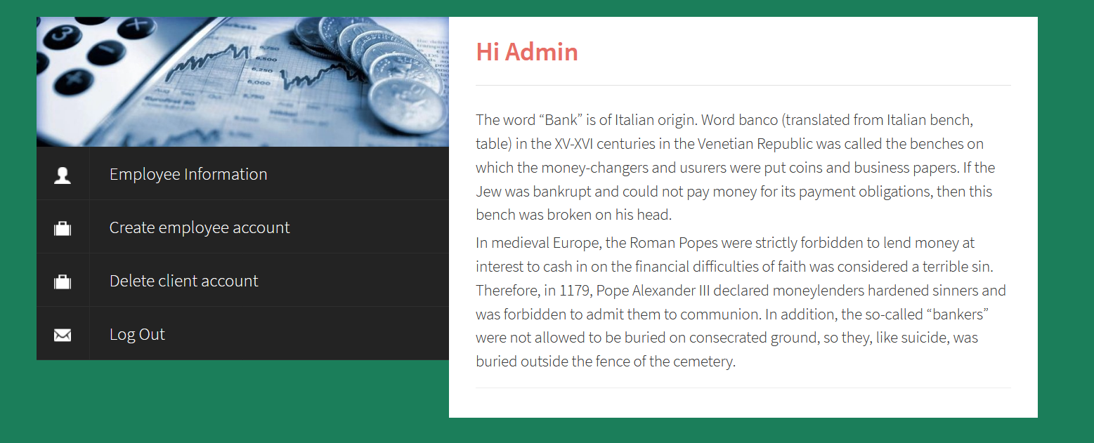

**Application Included:**

* **Employees Information—View and edit all employees’ information**

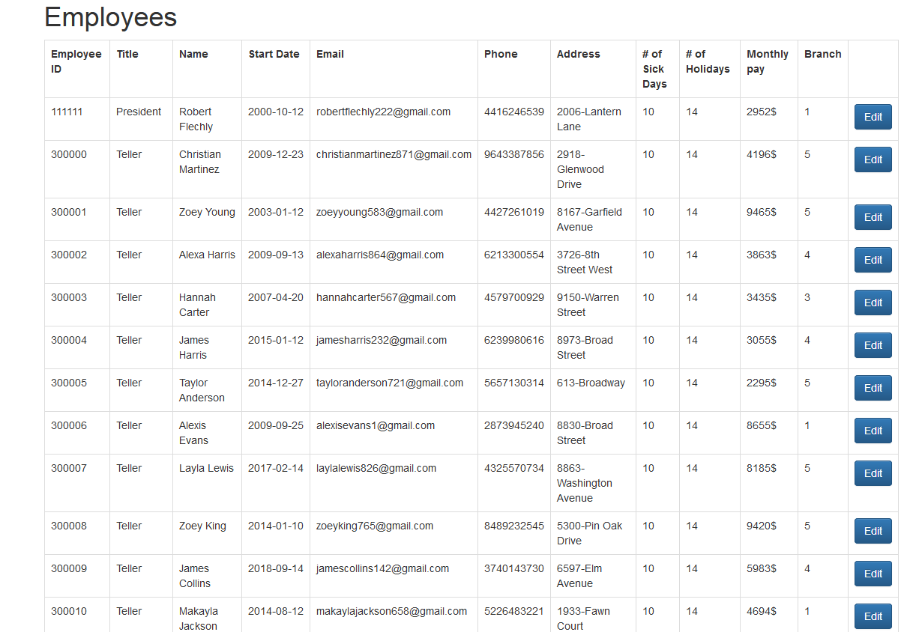

* **Create Employee account—Create account for employees by corresponding information**

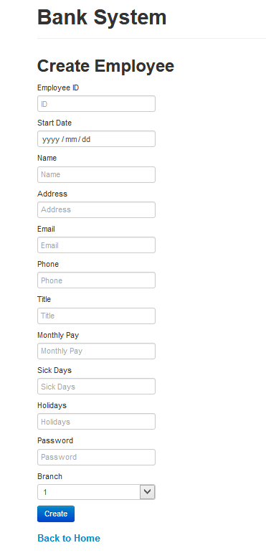

**Note: The UI of Signin and userpage are modified from templates of this website:** **http://www.cssmoban.com/**